

**UNIVERSITY MALAYSIA TERENGGANU**

**FACULTY OF OCEAN ENGINEERING TECHNOLOGY & INFORMATICS**

**[CSM3114]**

**FRAMEWORK-BASED MOBILE APPLICATION DEVELOPMENT**

**(GROUP 1)**

**ASSIGNMENT 1**

**“ BADMINTON COURT APPLICATION”**

**PREPARED BY:**

**NOORNAJWA AMIRAH BINTI ZAKARIA**

**(S61410)**

**PREPARED FOR:**

**DR. MOHAMAD NOR BIN HASSAN**

**[*BACHELOR OF COMPUTER SCIENCE (MOBILE COMPUTING) WITH HONOURS*] SEMESTER III 2022/2023**

**Table Of Content**

**1. 0 Executive Summary Of The Prototype 1**

**2.0 Ptoyotype Design 2**

**3.0 User Interface Application 3 - 4**

**4.0 Potential Commercial Value AndPricing..................................................................................5 - 6**

**5.0 Lesson Learned.................................................................................................................................7**

**6.0 Conclusion.........................................................................................................................................8**

**7. 0 References.........................................................................................................................................9**

**1.0 EXECUTIVE SUMMARY OF THE PROTOTYPE**

There are several main goals in creating a prototype Badminton Court Application at Universiti Malaysia Terengganu (UMT). Among the first, it helps improve user experience which is UMT students with the presence of design elements based on user interaction. This includes optimizing buttons, text and error messages for those who do not enter all the information. It makes the overall user experience better when using this app. Secondly, it aims to validate the concept of the application by ensuring that users can easily navigate from the main screen to booking details and court selection. Finally, the prototype serves as a testing ground for core functionality, enabling a thorough evaluation of screen navigation, data input and the court selection process to ensure smooth operation.

Next, there are the key objectives of the prototype for this Badminton Court Booking Application. This includes ensuring that the design is easy for users to understand when using it, especially when filling in booking details and badminton court selection information.In addition, the objective of this application prototype is also to ensure that this application is simple that focuses on responsiveness and speed so that it is easy for users to make reservations. Finally, evaluating the effectiveness of the error handling mechanism in the app is also one of the objectives of the prototype for this application. For example, if the user does not complete the user's information that has been provided in this application, an error message will be displayed so that the user completes all the information so that no problem occurs.

For the development stage, it starts with finding ideas and gathering requirements by sketching a wire-frame that helps to know what needs to be in this application. Next, prototypes also play an important role in shaping things to come. It acts as a basis for making decisions about adding features, selecting designs, and creating user flows and overall flows that guide the project as it progresses.

**2.0 PROTOTYPE DESIGN**

**2.1 Wireframe**

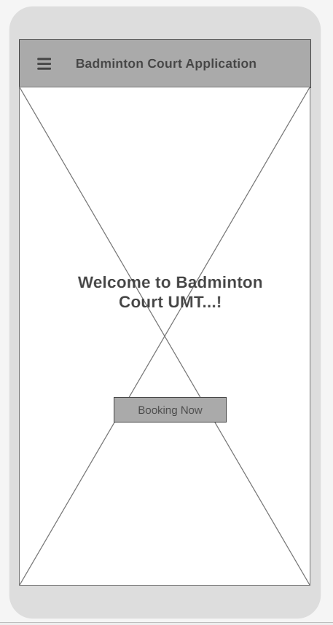 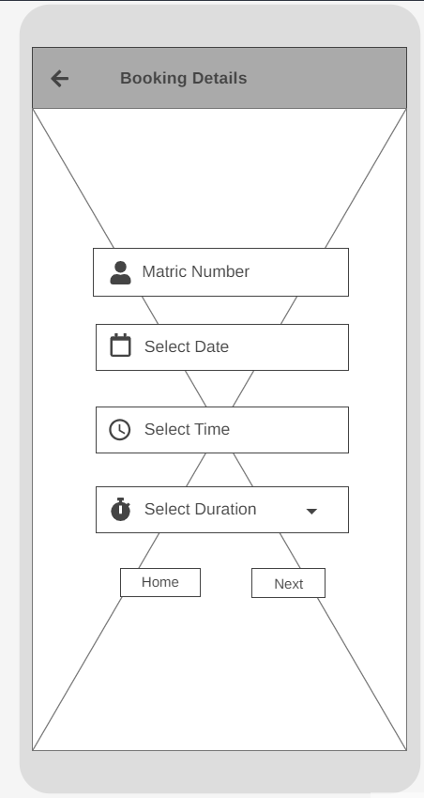

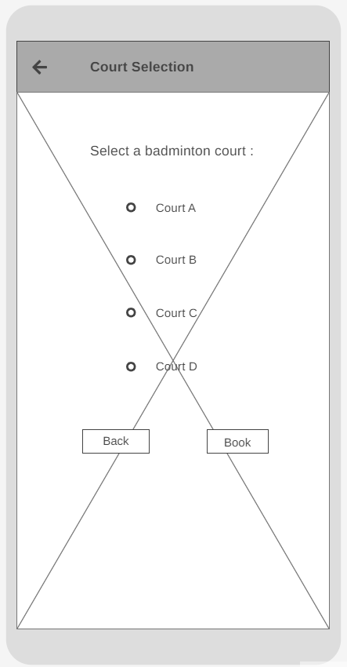

**3.0 USER INTERFACE APPLICATION**

**3.1 Home Screen**

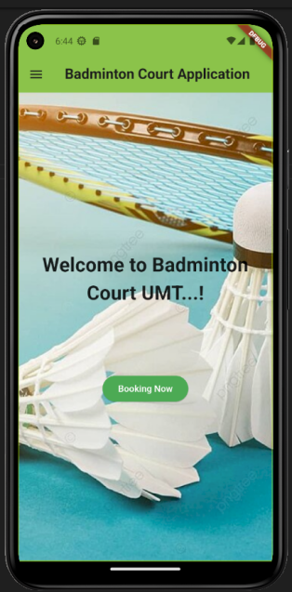

It has a drawer in the app bar for the home screen. When a user clicks on the drawer, a navigation drawer containing the booking details and the court selection will appear, allowing them to access either screen. It also has a "Booking Now" button that, when clicked by the user, takes them to a new screen with the booking details.

**3.2 Booking details screen**

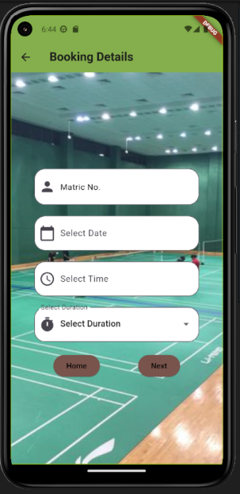

Next, the user must enter their matric number, choose a date and time, and choose a duration on the booking details screen. The lengths are one hour, one and a half, and two hours. Once the user has finished entering, they can select the court on the following page by clicking the "next" button. However, the user can click "home" to return to the home screen in order to cancel the reservation.

**3.3 Court selection screen**

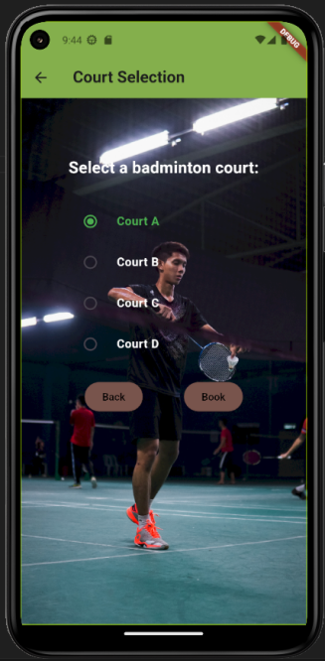

Lastly, the user must choose between courts A, B, C, and D on the court selection screen. If the user wants to change the information they entered, they can click the "back" button to return to the booking details screen from this screen. The user can click the "Book" button after verifying the information they entered. The data that the user enters in the show dialog will include the court selection, matric number, date, time, and duration. However, an error message will appear if a user does not enter all the information, and a message advising users to enter all the information before booking will appear.

**4.0 POTENTIAL COMMERCIAL VALUE AND PRICING**

**4.1 Commercial Value**

Badminton Court Application are highly valuable from a business standpoint, especially in academic environments where effective administration of the badminton courts is crucial. The application measures the time, date, and duration of using the badminton court, which simplifies the booking process and addresses the challenge of university students competing with one another using university facilities like this badminton court. It contributes to a more orderly and fair environment. Improved resource management, shorter wait times to use the badminton court, and higher levels of student satisfaction at UMT are some possible advantages. Organizations that implement this solution could see an increase in student satisfaction and operational efficiency, which would improve their reputation for offering more effective facilities at UMT.

**4.2 Pricing**

The Badminton Court Application's pricing plan presents a strong commercial proposition. Our pricing structure guarantees a fair and efficient booking process because we understand its great value for effective badminton court administration is crucial. The application addresses issues with students fighting for court access by tracking usage metrics like time, date, and duration, creating a more fair atmosphere.

For this app, students must pay RM15 for a lifetime subscription. Additionally, students can use this application for a small monthly subscription fee of RM3. This affordable fee schedule not only ensures fair access to the badminton court but also enhances resource management and reduces wait times.

The Badminton Court Application pricing model, which prioritizes effectiveness, student satisfaction, and operational excellence, is in line with the objective of advancing UMT's position as an affordable and easily accessible sports facility provider. By subscribing to this service, students can experience a smoother and better badminton court experience, which increases the success and satisfaction of the entire university community.

**5.0 LESSON LEARNED**

Several important lessons were discovered during the development of the prototype for Universiti Malaysia Terengganu Badminton Court Application. First and foremost, the dedication to user-centered design became apparent as a key takeaway, stressing the enhancement of the user experience via components of design customized for user interactions. This emphasizes how important it is to take end users' requirements and preferences into account when designing an application.

The significance of comprehending and maximizing user interactions was highlighted by the thorough examination of user flows, which included everything from the home screen to booking information and court selection. The importance of careful user flow design in producing a smooth and simple user experience is emphasized in this lesson.

Finally, the realization that prototypes form the foundation for directing the project's advancement brought attention to the necessity of adaptability and flexibility in the development process. This lesson emphasizes how crucial it is to be flexible in order to adapt to changing requirements and feedback in order to guarantee the success of the application. All things considered, these lessons add to a comprehensive comprehension of the development process and can guide upcoming initiatives for ongoing development.

**6.0 CONCLUSION**

In conclusion, through intuitive interfaces that expedite the booking process, Badminton Court Applications enable players to quickly and easily reserve the courts of their choice, doing away with the inconveniences that come with more conventional approaches.To put it briefly, a university needs to have a badminton court booking application. Students at UMT who wish to play badminton can reserve this badminton court online using this application. The app helps students as well as the UMT community by providing a set date, time, and duration for using the badminton court at UMT based on student bookings, eliminating the need for them to fight to get the badminton court. By doing this, the parties can assist indirectly. By using this application, the parties can obliquely assist UMT in better managing this university's facilities in an orderly and efficient manner.

**7.0 REFERENCES**

1. Flutter documentation. (n.d.). Docs.flutter.dev. <https://docs.flutter.dev/>
2. booklux.com, B. -. (n.d.). Best Badminton Courts Booking System: Software & Free App. Www.booklux.com. Retrieved January 5, 2024, from <https://www.booklux.com/en/badminton-courts-booking-system#home>
3. Online Court Booking. (n.d.). Michael’s Badminton Academy. <https://www.mba101badminton.com/online-court-booking/>
4. Wong, H., & Fei. (2020). UNIMAS BADMINTON COURT BOOKING APP. <https://ir.unimas.my/id/eprint/34740/1/Wong%20Hong%20Fei%20-%2024%20pgs.pdf>

‌